Unit 8 Assignment Instructions – CIS164 
For the Unit 8 Assignment we will be working on areas that we have already reviewed in our course to brush up on those areas. This will allow everyone time to fully comprehend what we have learned so far throughout the semester.
Please make sure to fully read each question to ensure that you answer each question per the requirement. Also, please ensure that all responses are in complete sentences, free of spelling and grammatical errors.
*Unit 8 Grading Rubric (95 Points):
Assignment Requirements | Maximum Points | Points Earned
1. Review - 1 | 0-25 Points
2. Review - 2 | 0-35 Points
3. Review - 3 | 0-35 Points
Points Deducted for Spelling or Grammatical Errors
Total (Sum of All Points)
*Directions for Submitting Your Assignment:
Complete your assignment ensuring all questions are answered based on the assignment requirements. When the Unit 8 assignment is complete, please save your file in the following format, “Lastname-Unit#.doc” (Example: Smith-Unit8.doc). You may also utilize a Word Processing software such as LibreOffice for assignment completion. In this case the assignment may be saved in .odt format, (Example: Smith-Unit8.odt). Then when ready submit your file to the “CIS 164 – Unit 8 Submit Assignment” activity for grading.

1. Review - 1
- Start the PyCharm IDE. Select “File->New Project” on the next screen. Under “Location” change the word “untitled” to “Unit8”. Then click the “Create” button.

- Highlight your “Unit8” project in the Pycharm IDE then right click. When you right click a menu will appear, from this menu select New->Python File. Then a dialog box will appear, in the “Name” field of the dialog box type “Unit8Review1.py”.

- Within your Unit8Review1.py file, you will need to create a function named ‘dividing’. This function will take one parameter value, which will be an integer.

- For the function you will use ‘Exception Handling’ with the use of the try and except statements to try and return the results of a number divided by the parameter value given to the function. If the parameter passed to the function is the integer value of zero then your function should return ‘You tried to divide by zero!’ through the use of the except ZeroDivisionError statement. *Note: Review Chapter 3 for this!*

- For your script, you will need to provide a screenshot showing your completed script, and you will also need to submit it in a text file, along with this document.

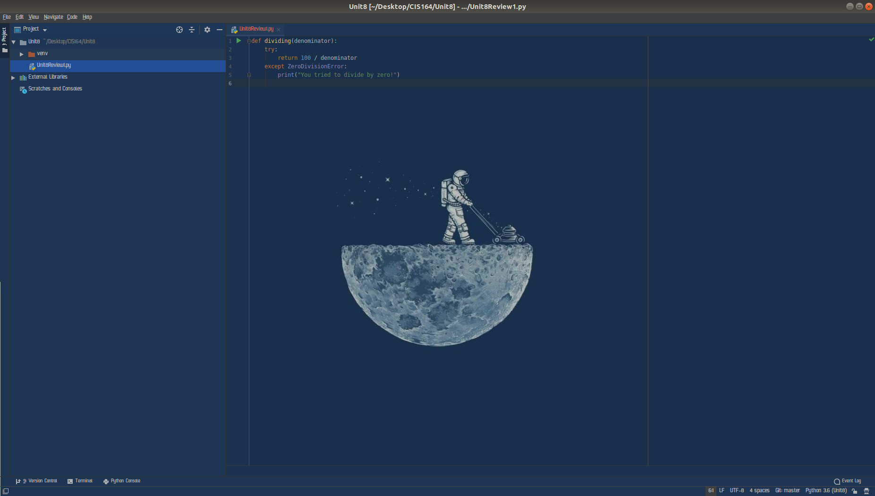

2. Review - 2
- Highlight your project “Unit8” then right click. When you right click a menu will appear, from this menu select New->Python File. Then a dialog box will appear, in the “Name” field of the dialog box type “Unit8Review2.py”.

- Within your Unit8Review2.py file, you will need to create a function named ‘indexvalue’. This function will take one parameter value, which will be an integer.

- Within your function you will have the following list:

locations = "Benson", "Douglas", "Sierra Vista", “Online”

- For the function you will use ‘Exception Handling’ with the use of the try and except statements. You will be taking input from a user in which you will be asking them to enter an index value to fetch within your list. If the user enters an index value that exists within the list, your function should return that value from your list with use of the index value, not an if statement!

- However, if the user enters an index value that would not exist within the list, your function should return the following, ‘There is no index value for that number within the list’ through the use of the except IndexError statement.

- For your script, you will need to provide a screenshot showing your completed script, and you will also need to submit it in a text file, along with this document.

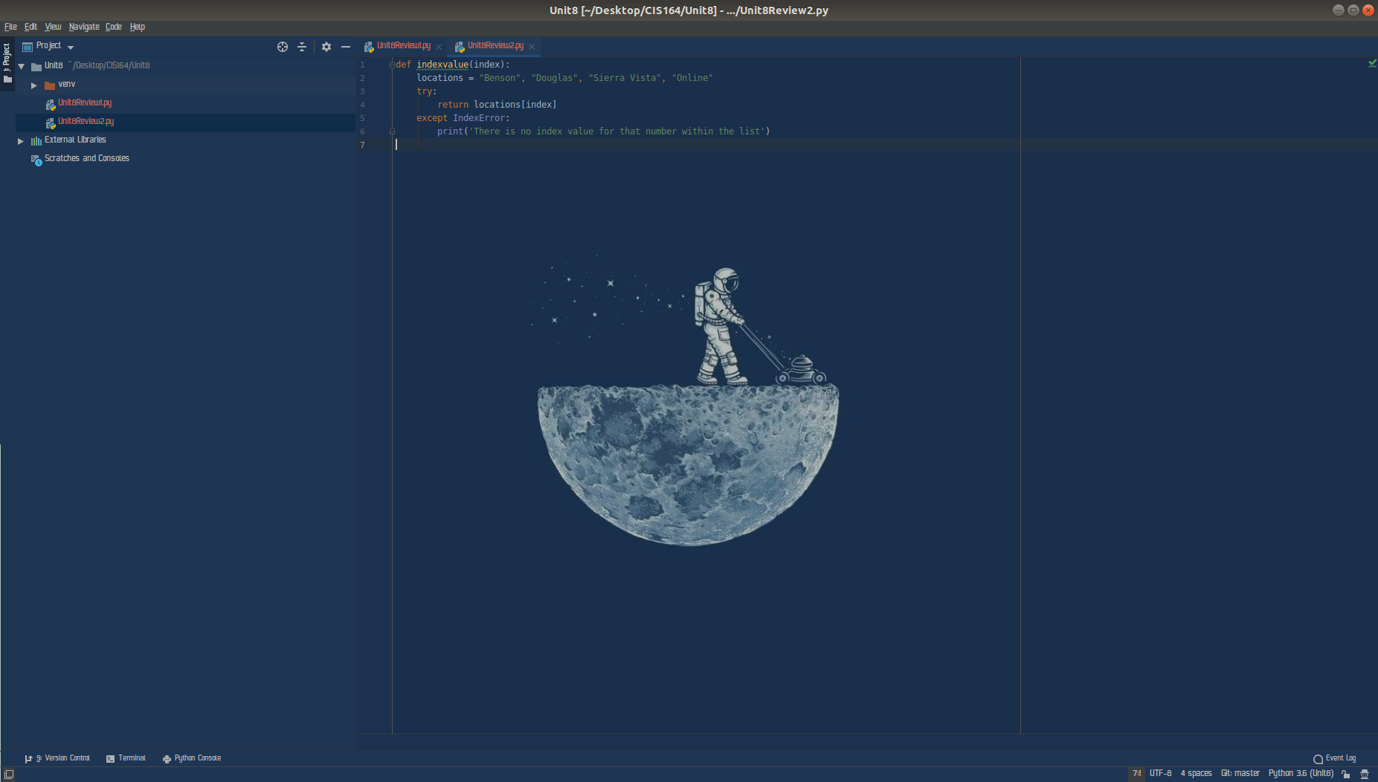

3. Review - 3
- Highlight your project “Unit8” then right click. When you right click a menu will appear, from this menu select New->Python File. Then a dialog box will appear, in the “Name” field of the dialog box type “Unit8Review3.py”.

- Within your Unit8Review3.py file, create a function named ‘dictionarysearch’ that will take one parameter value. Your function will have a dictionary that contains first the number value of the chapter for our book for chapters 1-5, then include the name for the chapter. For example; {‘1’:‘Python Basics’, ‘2’:‘Flow Control’, etc…….}

- Next you will ask the user to enter a number between 1 and 5 to display the Chapter names, or they can enter the value of zero to review all values in the dictionary. This value will then be passed to the function you created.

- If the user inputs a number between 1 and 5 you will need to return the value for the key using a method to retrieve the value from the dictionary, you should not have a list of if statements to display your keys and values! If the user inputs a 0, you will need to use a for loop to return all keys and values from the dictionary. If the user does not enter a 0, or a number between 1 and 5, your function should return the fact that they entered an invalid number to the user.

- For your script, you will need to provide a screenshot showing your completed script, and you will also need to submit it in a text file, along with this document.

